**Tutorial: AwesomeCo – Adding Images to the Page**

Let's add a graphical logo to the AwesomeCo site and talk about images.

Open the latest completed AwesomeCo folder from the last tutorial.

We've been given this logo to use for the site, and we'll place it in the AwesomeCo folder with the rest of our HTML files.

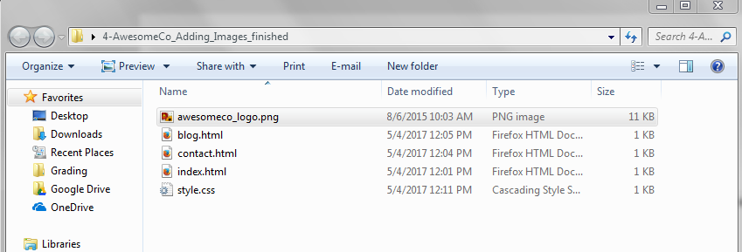

Let's open our AwesomeCo home page, index.html, and remove the `h1` tags and replace it with the awesomeco_logo.png logo. To do that, we use the `img` tag.

**<img src="awesomeco_logo.png">**

The `img` tag has a `src` attribute which points to the location of the image. This location can be a fully qualified URL to an image hosted on another web site, or it can point to a file on our web server. However, we have the logo and it's in the same folder as our pages and stylesheet so we can make a relative link to the image, just like we did with the stylesheet.

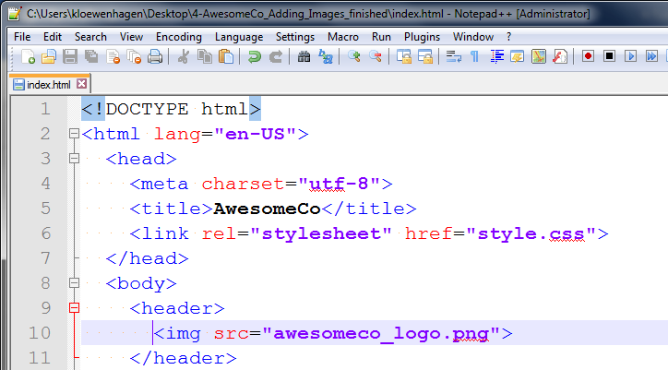

This is just enough to get things showing up on the page. However, it's not valid markup yet. Whenever we place an image, we must think about what would happen if the image couldn't be viewed. A blind person might visit this page and not be able to see the image. Or the image might not load because it was deleted or we made a mistake. We need to provide alternative text that gets displayed when the image isn't there. Overwrite the img tag with the img below and save the index.html file.

**<img src="awesomeco_logo.png" alt="AwesomeCo Logo">**

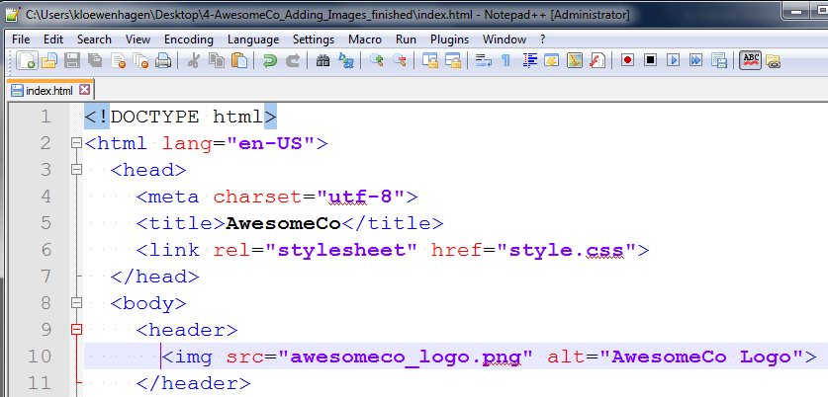

Finally, we really should specify the height and width of the image. This will let us more fully describe to the browser how much room the image will need so that the browser can make room for the image when loading the page.

To find out the height and width of the image, right click on the awesomeco_logo.png image found in the awesomeCo folder, select “Properties”, and then click on the “Details” tab. The width and height are displayed there.

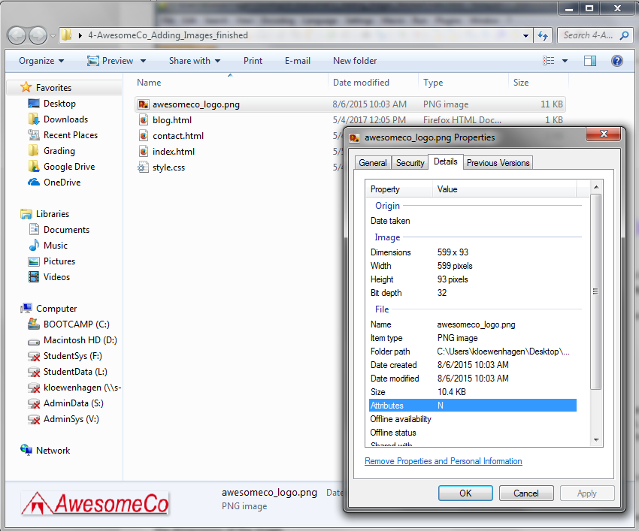

We can then use the `width` and `height` attributes to specify those values. Overwrite the img tag with the img below and save the index.html file.

**<img src="awesomeco_logo.png" alt="AwesomeCo Logo" height="93" width="599">**

We technically can use these values to scale up or scale down an image. But you should never do that. We are describing the content here. Don't take a huge image from a high quality digital camera and shrink it down using HTML. This will cause the end user to have to download that huge image and then use their CPU cycles to shrink it down. You should shrink it down in an image editor instead.

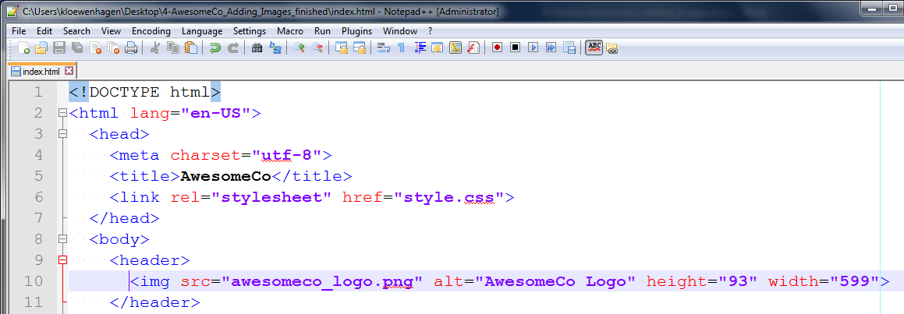

And that does it for this page. We can replicate this change to our other pages and now our site looks much more interesting than it did before.

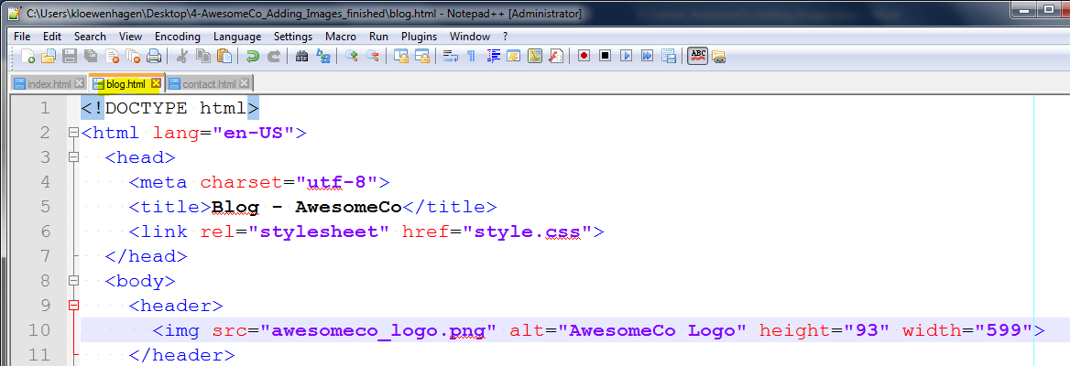

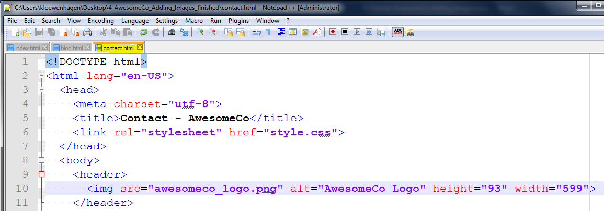

Remember, when placing images into your HTML, you'll need not only the image location, but the alternative text and the dimensions of the image.

See below to view the completed index.html page:

